Sent: 6/14/2016 8:56:13 AM
Subject: Fw: Cofounders Capital July 2016 Update

Investors,
Here's what's going on at Cofounders including information on our newest investment, status of current investments, press on our companies, invites to events and a heads up on our next capital call.

New Investment: Fokus Labs
We have completed our eighth investment. Fokus Labs is a company that makes the RE-vibe™ wristband for kids with Attention-deficit/hyperactivity disorder (ADHD). The wristband provides the wearer with periodic gentle vibration reminders (based on proprietary algorithms and bio feedback) that help the wearer combat distractions and stay on task. The patent-pending RE-vibe band provides a range of settings to allow parents the opportunity to shape their child’s behavior as an alternative, prevention or supplement to medication. We believe that many parents are seeking viable alternatives to both the cost and side effects of ADHD medication. Fokus Labs has already sold over 1,000 units and they are in use at over 300 schools across the country. Recently, the RE-vibe wristband has been featured in numerous publications including The New York Times. Because of the B2C nature of this business we decided to syndicate the round with BootStrap Advisers, a local hands-on fund specializing in B2C ventures. It is my hope to get this product certified as a medical device and over time spin this into a B2B company. We were able to negotiate a $1M pre-money valuation on the company. Apologies but there are no add on opportunities for this investment. You can see all of our portfolio companies here:
http://cofounderscapital.com/portfolio/
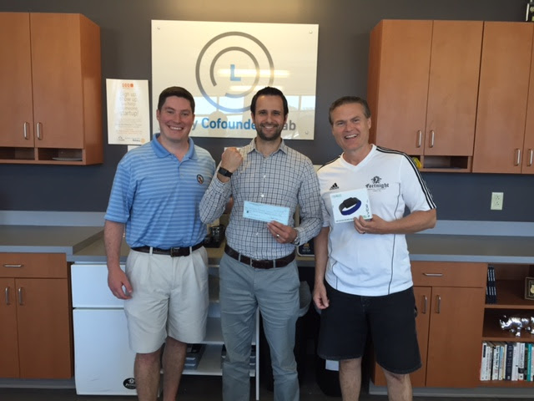

Next Capital Call
With this investment and one we hope to close early next month the fund will be about out of dry powder so please prepare for a capital call around the September time frame. This will be our first and only capital call this year. I plan to call 20% or your total investment commitment. Deal flow is very high and we are tracking many potential investments.

Events
Our next event will be a lunch a learn this Wednesday the 15th at the Lab at 12:00. This is free luncheon if you'd like to attend. A local law firm will be discussing the differences between types of copyrights, trademarks, trade secrets and patents. I'll be speaking at theStartup Grind Event in Winston Salem next week on the 23rd and at the Cary Chamber Planning Conference on the 21st of July. We hosted the Exit Event last month and had nearly 200 entrepreneurs attend the Cary Lab.
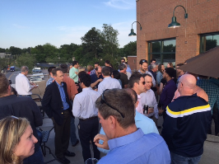

In the Press this Month

Forbes Article on EmployUS Disrupting the Job Recruiting Industry
FilterEasy Round Closes Investors bet on 5X Growth
FilterEasy Just Energy Partnership Announced
Reward Stock in WRAL Techwire Wins the Full Steam Award
Savii Care in TBJ Cofounders Invest in Savii
If you fly American Airlines check out the story on our FilterEasy boys in their in-flight magazine!

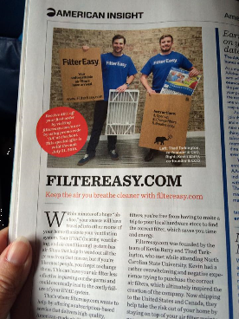

Portfolio Update
As I mentioned last month, with each update I will also update my opinion as to how well each of our portfolio companies is performing. As a reminder...
Green- doing well at or ahead of plan,
Yellow - near or somewhat behind plan,
Red - well behind plan and in danger
Black - dead, write off.

FilterEasy > Green
These guys are still killing it. They are ahead of plan and just finished their $3M raise. We also just closed a significant B2B deal with a major power company worth millions in additional revenue over the next two years. Even without that deal, revenue should grow by a factor of five to over $10 million this year alone. We've brought on a new director of marketing and a new full time CTO. B2B revenue is becoming an ever increasing part of total revenue and may overtake B2C revenue by the end of this year.

Canopy > Green
Canopy is on tract. We are purchasing a new trailer/team every week for the next two months straight. I initiated discussions with John Deere offering to use their equipment exclusively in exchange for volume discounting, financing terms and some co-marketing. We also starting doing in-store coffee/marketing stations at select Lowe’s stores.

Factivate > Red
The pivot to pre-built BI spreadsheet templates is progressing. We are selling these but not at a significant enough rate yet to seriously move the needle. There has also been some break through on the technology side that might enable our original vision of a universal spreadsheet like tool that can connect to and pull data from any cloud-based sales or marketing tool. I shall summarize with a quote from Monty Python..."I'm not dead yet!"

EmployUS > Yellow
This enterprise recruiting tool is still ahead of plan on the large employer side but behind on the getting consumers (what we call connectors) to use the app. We are learning. There was a flaw in our initial model in that we let employers choose which job openings they wanted to post in EmployUS rather than requiring them to place them all with us even those without a bounty. This led most employers to post only the most difficult-to-fill jobs with us making it hard for connectors to earn bounties. We have repositioned our offering and hope to see the ship slowly turn back on course. That said, the company has been in discussions with a possible early acquirer. I'd prefer to position them as a partner until we have created more value to justify a larger exit. We are keeping all options open at this point.

RewardStock > Green
The company continues to perform and get good press. Revenue is small but growing. We need to figure out a way to get more free press to drive users to the site. The vast majority of our early adopters are engaged couples planning for their honeymoon. I introduced the company to Wedpics and we are doing some interesting marketing together. The technology continues to improve and will soon be able to keep up with and automatically track all of our users' loyalty program miles and points.

Testive > Green
Testive continues to execute well although we are falling further behind plan on the B2C side. We do however have a number of promising large opportunities on the B2B side. The company may be doing an extension on their A round at the same terms as last year. After Tim and I have reviewed the use-of-funds plan and projections we will decide on our fund's level or participation in this.

Savii Care > Green
We've hired a director of sales who is working out well. Sales are basically at plan although the accounts are smaller than anticipated and taking a bit longer to implement. We are working with the company to address this. A new release went out last week providing significant new and long awaited functionality which should help us migrate towards larger accounts.

Fokus Labs > Green
One week in so I'm going with green!

How you can help
We are in due diligence with a company call Tesser Health that has a technology that can automatically review a self-insured employer's drug insurance claims data and produces a list of cost-saving interventions. These savings are usually in the millions of dollars per year. If anyone has expertise or contacts in the healthcare claims or benefit management space we would love to speak with you. We are also looking seriously at a company that tracks information on aircraft maintenance. Monetized as a lead generation system, it pulls massive amounts of information in from many sources including flight plans. Let us know if just happen to be familiar with this industry.

Closing
In summary I feel good about our portfolio in general, the caliber of deals we are tracking and the valuations we are getting. The lab is filling up. I'll close with the view from my office today.
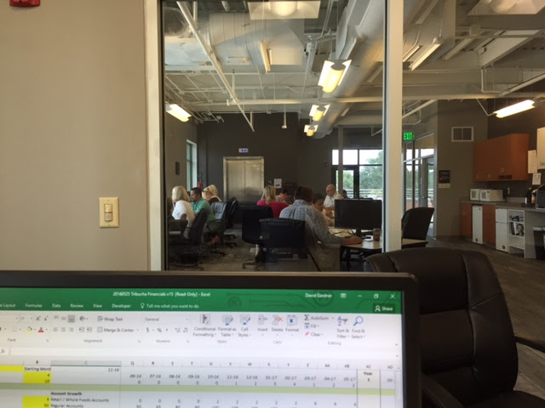

David Gardner profile
david@cofounderscapital.com
Cofounders Capital, LLP
919.244.3048

