Investors,
It's been an incredibly active seven weeks since my last update. Please read this to learn about our two new investments, the capital call due in May and how our portfolio companies are doing.

Next Capital Call
You will receive notice this month for your next capital call. It will be for 15% of your total commitment and due by the end of May. I lowered the amount down from the predicted 20% because two promising deals we were working on since last year did not pass due diligence. Our accounting firm, Fairview, will be sending notification and instructions to each of you on how to submit your wire or check.

Two New Investments!
I get excited about all of our investments but I am even more so about the two we closed this month. Here's why.

ImpathIQ
ImpathIQ is a health informatics engine used by emergency room doctors and staff. It reduces healthcare costs and improves patient outcomes and safety by providing continuously updated and validated clinical decision support within the electronic health record utilizing plug and play apps and pathways. This was arguably the most attractive deal we have done to date for several reasons. The four founders include three medical doctors and one PhD in healthcare informatics. We helped the team negotiate the rights to their technology from Wake Forest University tech transfer which has already received nearly a million dollars in non-dilutive grant funding for the project. The company has signed on three paying hospitals and we are taking them into Duke and Rex to pitch next month. We are very fortunate to have invested $375K on a $1.6M valuation to purchase 18% of the company. We are the only fund the founders reached out to for investment saying that they found my book online and after reading it decided that they only wanted to work with Cofounders. There is no press on this deal as it won't be announced until next week.

MapMyCustomers
I'm really proud of this one since it's the first startup we have lured away from Silicon Valley. They moved the company to Cary just to work with us and rented the second floor of the Cary theater below my office. MapMyCustomers is a CRM companion built by field sales professionals to meet the specific challenges facing outside sales executives. Their product empowers field sales teams to work smarter, faster and with greater efficiency to drive more sales. Sales teams use MMC to visualize their data geographically and strategically target customers while planning optimal driving routes. We invested $275K on a $2.4M valuations. The company already has a finished product and over $30K in recurring monthly revenue. We are the only investor in this already profitable business!
WRAL Techwire - Silicon Valley StartUp Moves to RTP after Landing Cofounders Capital
TBJ - Ex-Silicon Valley Entrepreneur Says Triangle Beats the West Coast

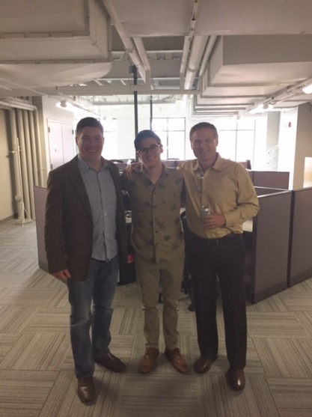

Cofounders Fund the News
The fund continues to gain recognition and deal flow with some great press this month in WRAL Techwire.
Cofounders Capital Rapidly Emerging as Triangle VC Power Player

Events
We spoke at and hosted a number of Events over the last 45 days promoting the fund and deal flow. Following are some of these events. Besides the events we hosted and spoke at below, we also attended a number of events around the Triangle not listed here. You can get advanced notice of all of our events, news and blog postings by following my tweets at @startuphats

* WRAL Exit Event: We hosted this at Fortnight Brewery and had over 150 entrepreneurs attend.
* Cary Leadership: I spoke to this group of future leaders at the lab this month.
* The State of StartUps: Tim spoke to over 200 entrepreneurs at this events In Wilmington
* NCSU Lulu Games: I was a judge again this year for this pitch competition.
* EVC Club: We hosted these groups from UNC and Duke at the lab.
* Carolina Sport Court Event: A pitch event at UNC
* Disrupt HR: We facilitated this event at the Cary Theater for over 200 HR professionals.
* Intern Round Up: We hosted an event for 22 interns to meet our portfolio companies
* Financing Your Venture Event: Tim spoke to this group
* Reverse Pitch Greensboro: Tim spoke to over 130 entrepreneurs here
* Fuqua VC Conference: We spoke to around 50 students here looking for funding
* UNC Innovate Carolina Conference: I served as one of the panelists
* Charity Shark Tank: I also played one of the sharks after the Embers performed to raise money for Triangle charities

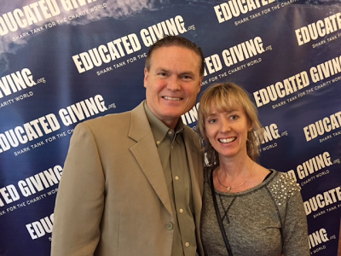

Portfolio Update
Here is my current assessment of each portfolio company. You can see a short overview of all of our portfolio companies at http://cofounderscapital.com/portfolio/

Green- doing well, at or near plan
Yellow - somewhat behind plan or other trouble
Red - well behind plan and in danger of failing
Black - dead, write off.

FilterEasy > Green Green
FilterEasy remains on track and growing steadily. As I mentioned before we have been looking for a B round of funding and were fortunate to receive multiple terms sheets this month. The board has signed a terms sheet for a $5M investment based on a $31M post valuation. This valuation is a solid up tick from our original valuation. You may recall that we also did a follow on bridge loan with a cap conversion fixed of $20M so it will now convert at that discounted valuation rather than what the new investors are paying. This is confidential information for now.
Benzinga: FilterEasy Pledges to Reduce Environmental Impact

Canopy > Green Green
Canopy is on a roll! Three acquisitions so far this year and on track to do around $4M in revenue at excellent gross margins. Hunt's background in M&A has proven to be a valuable skill set for this roll up of under performing landscaping companies. We are fitting out a new truck/trailer every other week with excellent lease terms we received through a contact of mine at John Deere. Canopy University was created to train all new teams in the Canopy Way and how to use our technology. We should end this year with over $1M in liquid cash.
Charlotte Business Journal - Raleigh Tech-Enabled Landscaping StartUp Enters Charlotte Market

Factivate > Red Red
Although still red above, "pink" might be a more accurate color now. Juan landed a $140K contract this month and received a $40K grant when selected Google Entrepreneur in Residence. He's bought us more time to try to figure this out.
The Harold Sun: American Underground names Juan Porras as new entrepreneur-in-residence

EmployUs > Green Green
EmployUs has recruited two new senior sales professionals out of the HR industry and one integrations specialist. It also sold it's first staffing agency this month proving that our market includes both large HR departments and larger staffing firms. Ryan raised an additional quarter million on a note from the NCSU WolfPack Investor Network.

RewardStock > Green Green
Unfortunately the acquisition discussions with Capital One Bank have been put on hold but they are still interested in an investment. The user base continues to grow and numerous biz dev discussions are underway with travel sites, banks, credit check vendors, etc. Several of you responded to my call for add on investments last month and the company has raised all of the additional funds it desires at this time.
Business Insider Magazine - The Value of Travel Rewards Points Change Daily But Now There's a Ticker

Testive > Yellow Yellow
The new CEO has raised around $350K of the $500K round so far. We put in a small amount to maintain our pro rata ownership. One quarter in and the company is at plan and showing about $100k less in burn than forecasts. Promising biz dev deal discussion are also underway. I fell a lot better about Testive but not quite ready to move into the green yet.

Savii Care > Yellow Yellow
We've worked a lot with Savii this month. Michelle was able to raise a few $100K and close a couple of new deals. The product looks great and we have made much-needed progress on her sales and marketing material. Again...getting closer to green but I'm not fully ready to change colors until I see next month's metrics.

Fokus Labs > Green Green
Fokus Labs continue to perform. The company is at plan and just won a $175K non-dilutive grant. The specs and vendor selection for version two of the product are complete. That work has begun with a hopeful ship date of October this year.

ParkMyCloud > Green Green
This company slightly exceeded forecast this month. Jay, the founder and CEO has started raising an A round of funding on the West Coast. The company should command a decent up tick in valuation but no terms sheets so far.

Tesser > Green Green
Tesser closed its first direct deal this month but it's channel partners are not performing as quickly as we hoped. We are working with the team to better train and arm their channel partner's sales teams. I'm not too concern yet.

Urban Offsets > Green Green
We closed a major deal with New York City! More important, this model has changed radically for the better. We are now able to avoid holding tree inventory and can purchase them as needed for the carbon credit exchange. This dramatically improves the company's cash forecast and need for additional funding.
1880 Magazine: Urban Offsets Profile

ServusConnect > Green Green
Servus Connect has closed it's second major customer and is close to securing a partnership with MRI, one of the maintenance industry's largest ERP vendors. Great progress this early in.

MapMyCustomers > Green
So far so good...

ImpathIQ > Green
So far so good...

Closing
Even though we closed two deals this month our deal pipeline is already full again. We receive about four new plans per day. It's great that I am able to report that at least one of our portfolio companies seems to be securing major VC financing at an increased valuation in almost every update I send out now. Feel free to call me if you have any questions.

