Investors,
Here's what is going on. The Summer has caused no slow down at the Lab, in fact, many days there are no seats available and we are having to upgrade our internet service to accommodate all of these potentially great startups. We usually see a bit of a slow down in the Summer but deal flow is as rich as ever with 4-5 opportunities per day contacting us. Below, Jimmy John's support our entrepreneurs by sending over lunch one day!

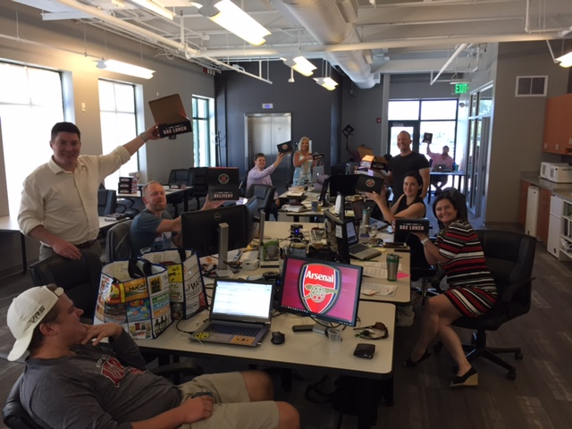

Next Capital Call
I do not anticipate another Capital Call until the end of the year or early next year.

No New Investments
We are currently in due diligence with three companies but are not ready to close investments yet with any of them.

Cofounders Fund in the News and Publishing
WRAL TechWire - Entrepreneur Explains why he left the valley and moved to Cary to work with Cofounders Capital.

NC Economic Development Report - Cofounders Lab Ranks

ExitEvent Article - On Super Star Recruiting by David Gardner

ExitEvent Article - Why Founders Don't Remain CEO by David Gardner

Events
We continue to promote the Lab and Fund all over the Triangle. I won't list all of our engagements this time but you can get advanced notice of our events, news and blog postings by following my tweets at @startuphats Below is a video interview I gave StartUpGrind.
YouTube StartUpGrind Interviews David Gardner about Cofounders Capital

Portfolio Update
Here is my current assessment of each portfolio company. You can see a short overview of all of our portfolio companies at http://cofounderscapital.com/portfolio/

Green- doing well, at or near plan
Yellow - somewhat behind plan or other trouble
Red - well behind plan and in danger of failing
Black - dead, write off.

FilterEasy > Green Green
FilterEasy has closed its $5M B investment round based on a $31M post valuation. A very solid up tick for Cofounders! This company is fully loaded and ready to scale. Revenue across all profit centers are trending better than plan.
PR NewWire - Kiwi Energy Partners with FilterEasy

Canopy > Green Green
You are probably seeing the Canopy trailers all over the Triangle now and in Charlotte. The company is fully funded by the Lowes investment and scaling at plan.

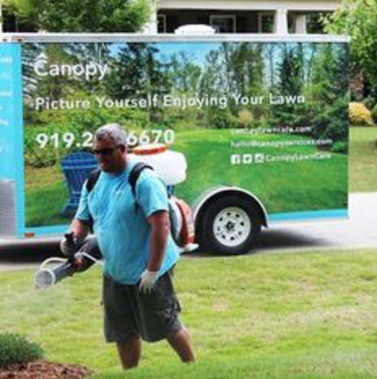

Factivate > Red Red
Factivate continues to hang in there winning another $140K contract. This is services work however and not strategic to the their core technology. A new release of the tech does appear to be more stable and ready for a relaunch. We are working to keep the company alive to get them another time at bat but unwilling to invest more funds until traction is demonstrated. We are also recruiting a co-founder to help Juan.

EmployUs > Green Green
EmployUs is performing at or near plan and will close it's largest deal ever at $460K this month. The company has developed two initiatives; one for major employers and one for staffing agencies. This team sits right in front of my office every day so I know how incredible hard they are working.

RewardStock > Green Green
Jonathan has hired a new director of marketing who is starting to move the needle. Two promising partnerships are getting closer to the finish line but not there yet. Although still a small user base at this point, the metrics are solid with good revenue per user. Lots of new functionality added so check it out again. The company has adequate working capital at this time.

Testive > Yellow Yellow
Testive is technically ahead of the revised but somewhat handicapped plan. The new CEO has been unable to bring in a serious next round of funding. I have argued that the company cannot afford this CEO without the capital he promised to bring to the table. The company continues to grow but will not achieve cash flow neutrality with it's current expense structure.
Global Premier Soccer Partners with Testive

Savii Care > Yellow Yellow
Savii added six new accounts last month fulfilling a promise to me that they would only focus on and sell larger customers. They are recruiting one of my old CTOs who would be a windfall for the company. Savii needs another cash infusion which I am reluctant to do without some major changes/addition to management.

Fokus Labs > Green Green
Fokus Labs revenue has slowed down a lot this summer but this was an expected seasonal variation. The company is cash flowing over all and is a finalist for a $1M non-dilutive grant. Once version 2 of their wearable is released late this year, the company will truly has a SaaS-based recurring revenue stream.

ParkMyCloud > Green Green
Good technical progress this year. The company now supports the three largest virtual cloud platforms on the market moving ever closer to their vision of being the one dashboard for managing all virtual servers. New customers include Microsoft. The company is, however, running out of money but there are deep pocketed investors around the table who remain bullish on this technology.
Mspmentor - 900 million wasted in azure spend

Myxx > Green Green
I'm pleased with the progress of the Myxx team. Although revenue is minor at this stage, they are piloting with multiple grocery store chains and brands. Amazon's acquisition of WholeFoods has sent a shock wave through the industry warning that if these traditional players want to survive, they will need better automation and shopper experience.
Storebrands- Myxx turning recipes int convenient grocery lists

Tesser > Green Green
Tesser has signed on some healthcare brokerage companies in what looks to be developing as a channel strategy. We have been approached by a private equity fund to acquire the company and we are going down that path. They are very eager to acquire but no numbers have been thrown out at this time. If the number is in the ball park of a good return for the Fund then I will fly down to Florida and negotiate the terms.

Urban Offsets > Green Yellow
We were disappointed that $240K in revenue from universities did not materialize as forecasted but the company has wisely shifted resources over to selling private companies. This seems to be a much shorter sales cycle but I'm moving the company into the yellow until it proves out. At the birth of Tim's first child the company gave him, what else, a tree!
MadeInGSO - Shawn Gagne's Trees

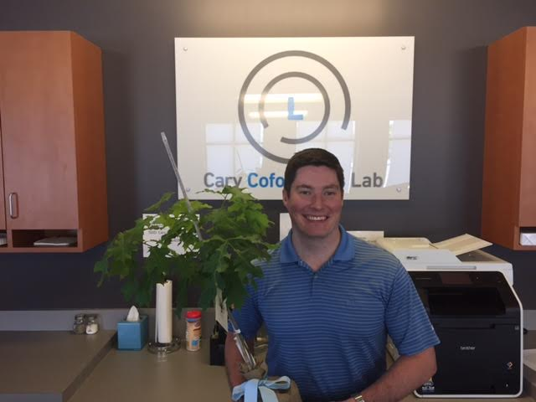

ServusConnect > Green Green
Servus has finally completed a full integration with MRI, the largest ERP in their space and is systematically targeting MRI customers. Revenue is solid and growing but the company is taking a productivity hit right now as the CEO is recovering from hip surgery.

MapMyCustomers > Green Green
Growing at plan but having a difficult time recruiting the more senior staff needed. They rented space below my office and run up to talk with us almost every day. I have no doubt these guys will make it happen.
ProductHunt Features Mapmycustomers video

ImpathIQ > Green Green
I am super impressed with doctor Iltifat Hussein. He has closed another major hospital unannounced as of yet. The new sepsis protocol is almost complete. One major win for the company this month... we were able to recruit Bill Pully, the president of the NC Hospital Association, onto our board. To my knowledge Bill has never accepted a for-profit board seat. His endorsement and connections will be very significant for ImpathIQ. Below, Iltifat stops by to show me his very first revenue check.
WRAL- Cofounders Invest in Healthcare Informatics Company
Mobihealthnews - Impathiq raises 350k to improve emr

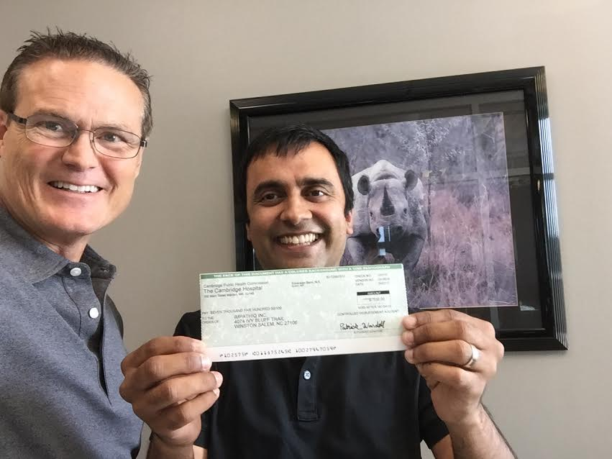

Closing
I feel a change starting to occur as Tim and I are spending more time now helping existing portfolio companies than trying to find and vet new opportunities. We will probably only do 2-3 more new investments our of Fund I and keep the remaining 24%-30% of our dry powder for bridge rounds protecting our investments. Call or swing by anytime if you'd like more information.

