Fund I Investors,
Hope your new year is off to a great start. Apologies that my last updated sent in late November was titled "September". I forgot to change the subject line on my template before sending but this is corrected on our website. I generally send these updates our about every 60 days. Here's what's going on.

Next Capital Call - NOW
As expected, you will receive a capital call notice this week from Fairview, our accounting firm, for 15% of your total fund I commitment. Please read this carefully as our bank and wiring instructions have changed. If you are mailing a check, you can use the same address as always. Please make your best effort to send your capital contribution in promptly. I would not anticipate another Fund I capital call until late this year or next year.

Fund II Closing
Thanks to all of you that are participating in Fund II. We are thrilled to have some of the most influential CEO's and entrepreneurs from around the Triangle supporting us. Final closing documents will be sent out later this month. There is still room to get in on Fund II if you would like to discuss this with us. We are thrilled to announce that Vickie Gibb will also be joining our team as a Fund II venture partner. Vickie is a analytical marketing expert and entrepreneur with an EE from Duke and MBA from UNC. We already have some very exciting companies we are vetting for Fund II.

Vickie Gibbs

Investments
We closed two new investments in the last 30 days! These will most likely be our last new investments from Fund I.

FeedTrail: We have been working with these entrepreneurs for about eight months. The company’s flagship product is a customizable application designed to solicit specific and timely feedback from customers to help ensure high customer satisfaction and retention. FeedTrail differs from traditional survey providers in that it helps businesses engage with and learn from their customers during their service experience. Two of the founders will be moving to Cary next week and working out of our lab. During our due diligence process the company closed several healthcare systems and already has around $30K per month in recurring revenue.

Looma: Cole, the founder of this startup has been working out of our lab for over a year now. There were many starts and stops as we vetted this venture but he continued on without salary or funding until we were able to overcome all obstacles and at last fund him this month. Cole will be deploying hundreds of advertising tablets onto grocery retail isle shelving across the state and pushing buy-local story-telling short promotional clips down to his digital network right next to the products being promoted. We will start with over 200 Harris Teeters locations as our pilot customer in the craft beer and wine isles. The company can become cash flow positive on this first pilot alone and Lowe's Food is already in the works to be our next customer. The strategic investing group from Lowe's is also discussing funding Cole's next round pending a successful deployment.

Update on other Term Sheets

Revemed: We are still trying to close on ReveMed. This technology is an AI that crawls and maps complex interactive phone trees eliminating hold time and automating responses for laborious B2B workflows dependent on phone interactions such as payer pre-authorizations. Our terms were tied to to the successful sell off of a non-strategic part of the business which is expected to close this month. Depending on timing, this may be our last Fund I or first Fund II investment.

Stealz: We were unable to come to terms with Stealz. Because revenue projections were tied do closely to the successful closing and role out of two major franchises, we insisted on terms that utilized a floating valuation based on the amount of revenue actually achieved over the next year. Ultimately, the company was able to raise the round from investors who did not require this term. We are happy for the company and felt our offer was very reasonable. Our deal flow is of such magnitude that we do not have to do deals that don't check all of our requirement boxes. If you are interested in investing in this Stealz round individually, we are happy to connect you with the CEO.

Cofounders Publishing and Events

StartupGrind TV Interview with David Gardner

My TBJ critique of the NC VC Multiplier Fund got me in some hot water but also fostered meaningful conversations at all levels of State government.

My WRAL Column was on the Difference between Management and Leadership
Tim spoke at the Digital Health In The Triangle Event and the VCIC Competition at Duke as well as some MBA classes. There were not many events in December but there were a lot of company holiday parties including a massive one at my house for all of our founders and their senior management teams. Sorry we did not have room to invite all of our investors as well.

Portfolio Update
The quarterly financial statements you get are not very helpful because our accounting firm has us value all investments at what we paid for them until there is an exit or follow on outside funding event. My updates give you more detail and our assessment of how the company is doing between funding events. Once again, the first color shows how we assessed the company in our last update and the second shows our current assessment. You can see a short overview of all of our portfolio companies at http://cofounderscapital.com/portfolio/ The password is "investorupdate"

Green- doing well, at or near plan
Yellow - somewhat behind plan or other trouble
Red - well behind plan and in danger of failing
Black - dead, write off.

FilterEasy > Green Green
Revenues continue to climb around $200K every thirty days. At our encouraging, the company has ended its exclusive relationship with supplier Flanders and now has a more robust supply chain consisting of three different filter manufacturers. The company made another acquisition and is seeking a manufacturer for our new patented Magic Filter. The FilterEasy guys are hanging with Mark Cuban this week at the CES Show in Las Vegas. Can't say I approve of the new executive company uniforms but there were an attention getter!

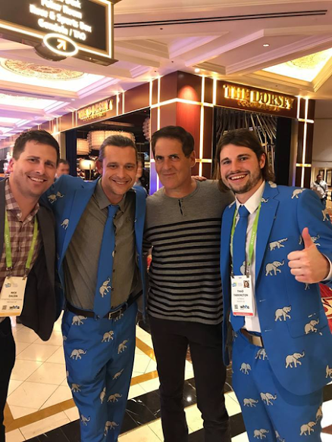

TBJ FilterEasy Acquires Competitor
WRAL Profiles FilterEasy

Canopy > Green Green
Canopy continues to grow fast adding a new truck and trailer about every week. The new office in Cary is working out well. I'll have more to report after our board meeting later this month.

Factivate > Red Red
Juan may be turning a corner. He has a deal with Fidelity and a large client in South America. It's been slow going since he's been funding R&D through his services work to stay alive. The revamped product now seems stable and ready for a relaunch. We shall see. We've told the team that we can't fund them again until they have repeatable and reference-able customers.

EmployUs > Green Green
This team continues to grow and drive revenue with several new pilots starting this month including Investco. It passed a major security audit last month leading the way to bigger enterprise customers. The CEO is also experimenting with a promising additional revenue stream and actively raising their A round at a solid uptick in valuation.

RewardStock > Green Green
RewardStock has kicked off it's pilot partnership with Experion and is in discussions with other potential partners. We have encouraged the CEO to focus on these deals/pilots rather than driving incremental consumer revenue because it does not have the cash reserves to meaningfully drive organic traffic. Travel tech is fast becoming a very hot space but we are tarting to get concerned about Jonathan's cash reserves.

Testive > Green Green
Testive pushed it's last raise to over $1M and is deploying that capital as planned. I'll have more information after our board meeting this week but that info will not make it into this update.

Savii Care > Yellow Green
The new CEO and CTO are fully engaged and starting to move the needed for Savii. Putting this new leadership team in place was painful but clearly the right decision. We are getting the information we need now to help steer the company. I'm thrilled with Sean, our new CEO. There are several articles below about the new raise and CEO. The company has a new plan and forecast which they are achieving so the color technically goes green this month although I'll add that there is still a long ways to go. There is a little money left still on this raise at a very attractive valuation should anyone be interested in doing an add-on.

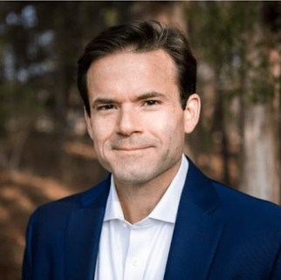
Sean Fitzgerald

Market Insider, New CEO and CTO at Savii
WRAL, Savii gets new CEO
Techwire Savii Raises over $400K

Fokus Labs > Green Green
There is a lot of money around the table for Rich's A round from RTP Capital, Wolfpack Investor Network and others but we are still looking for a lead investor. We are also going down the path with a potential acquirer that is flying down to negotiate with us this month. The fully automated bio-feedback SaaS based version of the product should begin to ship next month.

ParkMyCloud > Green Green
PMC had a good 4th quarter adding revenue and some more big logos. I am concerned that the company is running low on cash but we do have a terms sheet for the next round which we are negotiating and will probably do some variation of. It is not what we wanted but still a solid uptick in valuations. Good press in that we just found out that PMC was selected as a 2018 Channel Influencer. This will be announced soon. It is rare for a small company to get this recognition.

SDX PMC Automates the Cloud!
Startup 50 PMC selected and profiled as fast 50 startup company
SDX PMC Automates Cloud Savings

Myxx > Green Green
Monica has just about completed her $750K raise lead by RTP Capital, Charlotte Angel Partners and others. Online grocery tech has really heated up in VC circles. The company received an unsolicited call from Pinterest last month wanting to talk. Recipes represent the largest user topic category for Pinterest but they have very limited ways to organize and monetize the category. We have been engaged in an acquisition discussion with another company and will being traveling to see how good of an offer they will make later this month. Myxx has outgrown our lab space. They want to stay close to they are renting the floor below our lab.

WRAL News Smart Shopper Recommendation

Tesser > Green Yellow
I'm really starting to get concerned about Tesser so I'm going yellow this month. The big company-making deals just don't seem to be closing. We should know about one in a couple of weeks but in the meantime we've asked the company to cut way back on expenses. If this deal does not close as expected I'm going to have to dedicate a lot of time to help the team figure out what's not working. The value props are strong but there is a very complex ecosystem to navigate in the self-insured employer employee benefits space.

Urban Offsets > Green Green
Urban offset continues to hit it's numbers. Although up and down, the company have been averaging around $100K per month in sales lately! Bridging this company a few months ago was the right decision. Big news this month is their partnership with Delta Airlines and Duke University. There will be a kick off press event in Durham on 2/24 announcing the partnership lead by Delta's CMO and the major of Durham as well as senior executives from Duke.
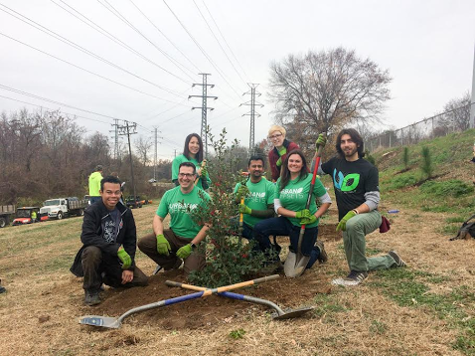

ServusConnect > Green Green
Servus is finally deploying the rest of it's original beta customer's locations. Cash flow is improving since we got them to negotiate pre-payment term with their larger customers. The company has a large pipeline of customers through their integration partner MRI. They are collecting good metrics with customers starting to really prove out their value propositions.

WRAL Techwire Servus Connect adds to it's seed round

MapMyCustomers > Green Green
MMC has hired around 25 people in the last sixty days. The company booked over $70K in revenue this month! Matt, the CEO and founder, is in India this month working with the company's development team there. He is the still wearing the CTO hat but we are encouraging him to hire a CTO now and focus more on his other company roles. MMC is performing at plan and the customer profile is shifting to larger enterprise type accounts as we had hoped. This will be one of our winners.

ImpathIQ > Green Green
ImpathIQ continues to excel as one of the very first apps in the Epic and Cerner app stores. After already winning over $1M in non-dilutive grants the company has applied for another with a good probability for winning it. They are in the final stages of negotiating a deal with the Palmetto Healthcare System in SC this month. We also helped the company negotiate some services work that is basically funding all of our R&D expense for the next product module.

FeedTrail > Green
So far, so good. We just ordered over 200 commercial tablets for our beta product with Harris Teeter. Unfortunately, they are being shipped to my house!

Looma > Green
Obviously at-plan the first week in. Actually ahead of plan since closing High Point Regional Hospital last week. Press on FeedTrail and Looma closings will be out by my next update.

How You Can Help - please
We are crazy busy right now working with our companies and trying to close Fund II. The most helpful thing you can do for us right not is introductions. If you know of anyone that might be interested in learning about our second fund, I would really appreciate the introduction. Please also keep in mind that our companies are always hiring especially developers and proven sales talent.

Closing
We are thrilled to have Savii back on track and also really excited about our two new investments this month. There is a flood of positive activity going on now with just about all of our companies. I feel fairly confident that we will have our first exit(s) and realized gains this year. It would be nice to be sending you all a check for a change! As always, feel free to call me or swing by the lab anytime. Finally, this picture of our dog has nothing to do with Cofounders but certainly seems to sum up January so far don't you think!

--
David Gardner Profile
david@CofoundersCapital.com
919.244.3048
Cofounders Capital
@startUpHats
The Startup Hats Book

