**Summary**

Now that we have two Funds I will be changing up how our updates go out a little.   Although many of you are investors in both funds some are only investors in one or the other so I am going to start sending out thee updates every 2-3 months.  The first will go to all fund investors which will include general information about Cofounders, our events, press and publishing as well as local market updates.   Following this email, there will be separate Fund I and Fund II updates sent to respective investors referencing the specific status of the companies in each portfolio.

**Cofounders Press and Publications**

Much of our success hinges on our ability to be involved and ubiquitous in the local entrepreneurial ecosystem.   If there's a deal to be had then we want to be the first to know about it and we want that entrepreneur to have already heard good things about Cofounders.  Here is what we have been up to on that front over the last 45 days.

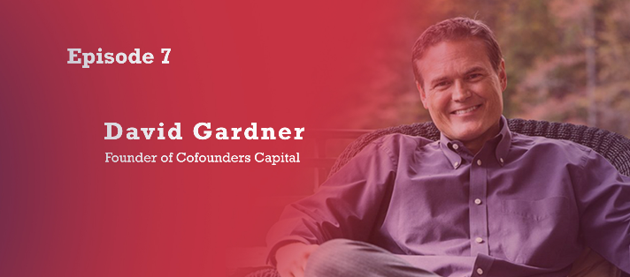

[ImagNovation - Tales from the Pros Interview - Video](https://urldefense.proofpoint.com/v2/url?u=https-3A__www.talesfromthepros.com_interviews_david-2Dgardner_&d=DwMFaQ&c=imBPVzF25OnBgGmVOlcsiEgHoG1i6YHLR0Sj_gZ4adc&r=w6_MrnIU2mZMYmuS-M3rpeVW0dKzlUXrm8fujFrMZeM&m=mRYRGO04QFlw4E3zRytXAQLUZ3ROBspj1eoJEumRm2s&s=ppsvVXfRsGhGVifCWR3NQOXBP37HPheU-iVfTzbZobQ&e=)

[Kotecki interviews Tim McLoughlin - Are tech investors to blame - Podcas](https://urldefense.proofpoint.com/v2/url?u=https-3A__www.jameskotecki.com_episodes_2018_4_24_cofounders-2Dcapitals-2Dtim-2Dmcloughlin-2Dplaces-2Dhis-2Dbets-3Fplatform-3Dhootsuite&d=DwMFaQ&c=imBPVzF25OnBgGmVOlcsiEgHoG1i6YHLR0Sj_gZ4adc&r=w6_MrnIU2mZMYmuS-M3rpeVW0dKzlUXrm8fujFrMZeM&m=mRYRGO04QFlw4E3zRytXAQLUZ3ROBspj1eoJEumRm2s&s=Y_4cZz7FekF_9UI3xAtBma0fTg7D3vC0XpA-lIoGHFA&e=)t

[Port City Daily - Gardner Speaks to Wilmington  Entrepreneurs](https://urldefense.proofpoint.com/v2/url?u=https-3A__portcitydaily.com_local-2Dnews_2018_04_23_from-2Dmaking-2Ddonuts-2Dto-2Dmaking-2Dmillions-2Dsome-2Dvery-2Ddifferent-2Dstart-2Dup-2Dperspectives-2Dat-2Dfree-2Devent_&d=DwMFaQ&c=imBPVzF25OnBgGmVOlcsiEgHoG1i6YHLR0Sj_gZ4adc&r=w6_MrnIU2mZMYmuS-M3rpeVW0dKzlUXrm8fujFrMZeM&m=mRYRGO04QFlw4E3zRytXAQLUZ3ROBspj1eoJEumRm2s&s=s8A6FnM4XO06X3JRhRznBXlM3WkzZH8CXHvDhmiyVEY&e=)

[WRAL Techwire - Gardner on why Texting is not a tool for business](https://urldefense.proofpoint.com/v2/url?u=https-3A__www.wraltechwire.com_2018_04_23_david-2Dgardner-2Dwhy-2Dtexting-2Dis-2Dbad-2Dfor-2Dproductivity_&d=DwMFaQ&c=imBPVzF25OnBgGmVOlcsiEgHoG1i6YHLR0Sj_gZ4adc&r=w6_MrnIU2mZMYmuS-M3rpeVW0dKzlUXrm8fujFrMZeM&m=mRYRGO04QFlw4E3zRytXAQLUZ3ROBspj1eoJEumRm2s&s=925-psUfZuGayRXJgJRsFXRErEQxtfn9BWEt7NnYi2M&e=)

[WRAL Techwire - Cofounders Closes on Fund II](https://urldefense.proofpoint.com/v2/url?u=https-3A__www.wraltechwire.com_2018_04_04_cofounders-2Dcapital-2Draises-2D20m-2Daims-2Dto-2Dleverage-2Dcash-2Dto-2Dattract-2Dmore-2Dstartup-2Dfunding-2Dfrom-2Dout-2Dof-2Dstate_&d=DwMFaQ&c=imBPVzF25OnBgGmVOlcsiEgHoG1i6YHLR0Sj_gZ4adc&r=w6_MrnIU2mZMYmuS-M3rpeVW0dKzlUXrm8fujFrMZeM&m=mRYRGO04QFlw4E3zRytXAQLUZ3ROBspj1eoJEumRm2s&s=uY6sVHqU-UR5tAP5A8v2xYDGW-Ujt0j8TjhIJzp7sM0&e=)

[TBJ - Big Name Investors Flock to Cofounders Fund II](https://urldefense.proofpoint.com/v2/url?u=https-3A__www.bizjournals.com_triangle_news_2018_04_04_big-2Dname-2Dtriangle-2Dinvestors-2Dflock-2Dto-2Dnew.html&d=DwMFaQ&c=imBPVzF25OnBgGmVOlcsiEgHoG1i6YHLR0Sj_gZ4adc&r=w6_MrnIU2mZMYmuS-M3rpeVW0dKzlUXrm8fujFrMZeM&m=mRYRGO04QFlw4E3zRytXAQLUZ3ROBspj1eoJEumRm2s&s=FHCPUOmFquso8UjdK7flaClNANYJPRBr7tLIu313iJc&e=)

[WRAL Techwire Column - If you are an entrepreneur then you are a sales person](https://urldefense.proofpoint.com/v2/url?u=https-3A__www.wraltechwire.com_2018_05_15_david-2Dgardner-2Dif-2Dyou-2Dare-2Dan-2Dentrepreneur-2Dthen-2Dyou-2Dare-2Da-2Dsales-2Dperson_&d=DwMFaQ&c=imBPVzF25OnBgGmVOlcsiEgHoG1i6YHLR0Sj_gZ4adc&r=w6_MrnIU2mZMYmuS-M3rpeVW0dKzlUXrm8fujFrMZeM&m=mRYRGO04QFlw4E3zRytXAQLUZ3ROBspj1eoJEumRm2s&s=y4aFmxcIQ0WJuQGzYTNs7tvvK4-QdGyWMSyPpWtfYAQ&e=)

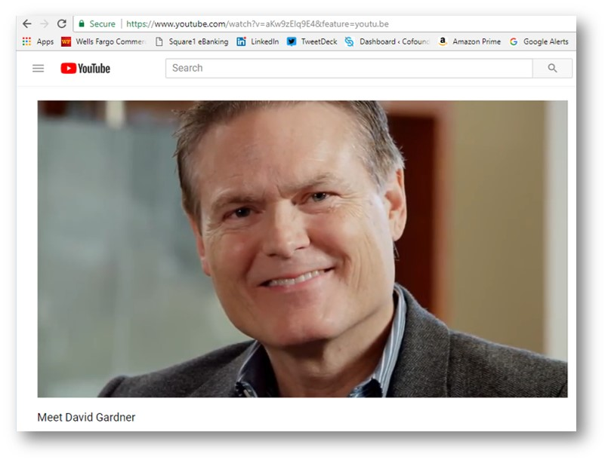

[Educated Giving Foundation Interviews David Gardner Promo - Video](https://urldefense.proofpoint.com/v2/url?u=https-3A__mail.google.com_mail_u_0_-23label_Folders-252FUpdates_162729bfeaaefa79-3Fcompose-3D163a20d9f422586b-252C163a2f70344c8663-252C163a2fc3bc445a8d-26projector-3D1&d=DwMFaQ&c=imBPVzF25OnBgGmVOlcsiEgHoG1i6YHLR0Sj_gZ4adc&r=w6_MrnIU2mZMYmuS-M3rpeVW0dKzlUXrm8fujFrMZeM&m=mRYRGO04QFlw4E3zRytXAQLUZ3ROBspj1eoJEumRm2s&s=szzIuAXVZCEDgZZDooXYy4j9xwWbjDgshDM8d6jXpa8&e=)

**Fund I and II Investing Tax Benefits**

As you may already know, the gains from all of our investments in Fund I and Fund II that we hold for five years or longer will be exempt from 100% of Federal taxes.   I will remind you to talk  with your CPA about this whenever we have a liquidity event and  make distributions.  Our companies qualify for this because we are first in investors in C Corp companies purchasing original issue stock.

**Events**

Tim and I have been busy attending and speaking at various events (list follows) getting the word out about our new fund.   We were especially honored to host several of our State's officials supporting early stage entrepreneurship at an event at my home with over one hundred in attendance.

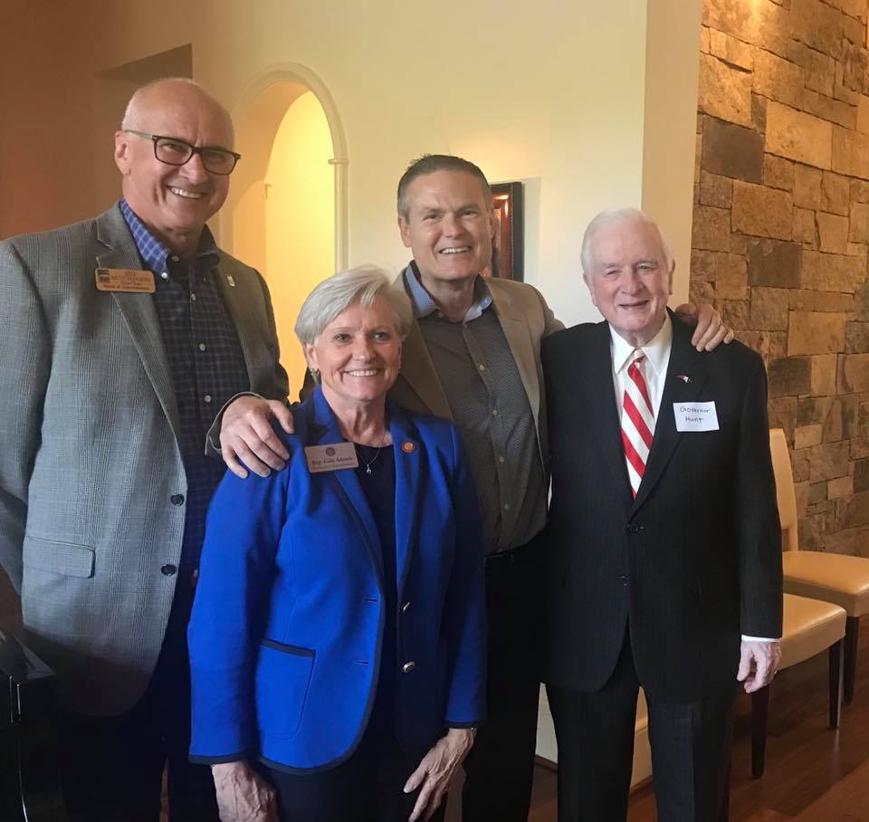

*Wake County Commissioner Sig Hutchinson, House Rep Gale Adcock and Governor Hunt*

UNC Carolina Angel Network VIP Reception

Credit Suissee FIN Tech Conference

Durham Underground HelpFest

Cary Leadership

UNC Innovation Showcase

NCSU Lulu Games

50 Group Meeting

Wilmington's Entrepreneur's Network Event

First Flight Center Low Country Boil

CED Members Reception

RTP Capital Dinner Pitches

NCSU Chancellor's Innovation Fund Presentations

Charlotte Collective Hustle SE Early Stage Investing Summit

NC Idea Grant Pitchs

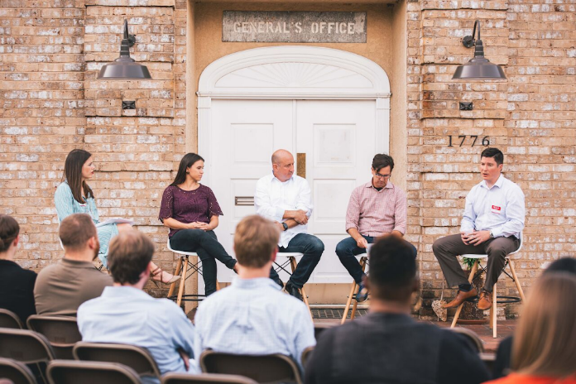

*Tim speaking at the Charlotte Collective Hustle Event*

**How you can help**

We are targeting corporations to finish out our Fund II raise.   If you have connections to local corporations that would like to make a good return investing locally while securing access to local innovation and technologies, please introduce us.    We also always seeking out developers and top sales persons for our companies.

**Closing**

We really appreciate Erik Frederick for conducting technical interviews and code reviews for us and Anthony Dilweg for hosting a focus group for us at his offices last week.   We'd also like to think Dick Daugherty and Stuart Phoenex for their help with NCSU.  It's crazy busy trying to finish out our raise, vet dozens of promising companies and maintain a high community profile but we are up to the challenge and enjoying the work.  Your individual fund updates will follow via separate emails.   Feel free to call or stop by the lab anytime should you have questions or just want to sit in meetings.