September 2018

Fund II Investors,
It has been a very busy summer as we sold one of our Fund I companies and closed on our first two fund II investments. We will also be closing on a third this week. Our first three portfolio companies are listed below. About every sixty days or so I will provide an update as to how each is doing. I'm very pleased with our first purchases and the deal terms we negotiated. We have added a few million to fund II on a rolling close but are still far short of our $50M goal. It is important that we achieve at least $35M in order to fully execute on our seed investment plus A round strategy so please do refer us to anyone that you think may have interest in what we are doing.

We have set up a sweep account with Square One bank so that funds we are holding in our account can earn some interest while waiting to be deployed. This will be added to our total fund return.

We have our first realized returns from Fund I what will be distributed this week.

We are adding four new interns for the Fall/Winter term.
Tyler Sipala (MBA Fuqua)
Rob Versaw (MBA Fuqua)
Glenn DeMarcus (MBA Kenan-Flagler)
Damon Hartye (MBA Kenan-Flagler)

Tim and I both became TechStar Mentors working with the MetLife FinTech Accelerator program this summer. We met a lot of great early stage companies. Tim was also a mentor and judge for the Riot Accelerator Program.

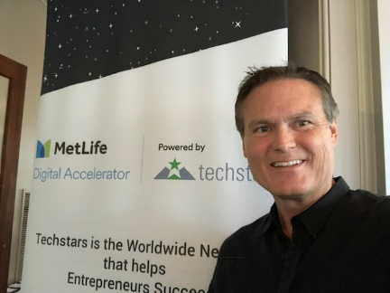

Next Capital Call
Our next capital call is expected early next year.

Portfolio Update
For those of you who were not in Fund I, this section of my update lists each portfolio company and our assessment of how it is doing. The quarterly financial statements you will receive from Fairview, our fund accounting firm, only takes direct cost and latest valuation into consideration. We know much more about the workings of these companies and try to provide you with more insights. Very soon, we will add all of our fund II companies to our website so you can review them anytime at http://cofounderscapital.com/portfolio/

Here is the color coding I use. The first color is how we rated the company in the last update and the second color is how it is rated in this update. Since we just acquired these, there is only one color for now.

Green- doing well, at or near plan
Yellow - somewhat behind plan or other trouble
Red - well behind plan and in danger of failing
Black - gone, sold or shut down

ContractorQuotes > Green
This company has a technology and technique for improving search engine optimization (SEO). We are investing $300K on a $1,035,000 valuation. The entrepreneur, Thomas, works full time out of our lab. Part of the use of funds for this venture is to make acquisitions of which two were achieved last month. The company is already generating revenue on a lead generation model. As this company is in stealth mode we are being a little vague about its specific tech and go-to-market strategy.

CareNexis, Inc. > Green
We invested $300K (up to $400K) on a $1.3M valuation. We are super excited about his healthcare IT opportunity as it has the potential to be monetized many different ways matching patient diagnostic codes to post acute care products and services to create individualized care plans. This company has been in diligence since late last year with the entrepreneur, Daniel, working out of the lab most days. Although we really like the technology, concept and more seasoned entrepreneur, we stuck to our model that our investment needed to fund a realized pilot project which was slow in materializing. With Medfusion pilot continually delayed, focus was shifted to pilots with McKesson which did materialize. Tim traveled with our entrepreneur visiting McKesson last week in Richmond. If anyone has contacts at a company that has a physician or discharge planning portal, like AllScripts, we could really use those introductions.

EasyVote, Inc. > Green
I still cannot believe the deal we got on this company. $1.2M for 40% ownership in a profitable company with deep proprietary technology. The company has a broad customer base with nearly 100% retention and is on track to have $1.5M in recurring revenue by the end of the year. This company would be valued anywhere at over $8M but our effective pre-money valuation is only 1.8M. We have been working with this team for the last four months.

Other Term Sheets:

ReveMed
I discussed the company in my last update. Although we really like the deep IP, vision and traction, we are less so excited about the founder/entrepreneur. He is a great sales person and visionary but not the person we believe should be at the helm. We have terms and are willing to invest provided this entrepreneur is willing to let us bring in a mutually agreed upon CEO. Other founders in the company are pushing hard for this as well so we have hopes that the current CEO/founder will agree to this provision or else we will need to walk.

EcoBot
We have a signed terms sheet with these founders. Diligence has been mixed. There is a strong need for the product but the market size is smaller than we anticipated and their IP is not very deep. Thanks to fund II investor, Erik Frederick, for helping with code diligence on this one. We continue to dig into competition and how portable this tech might be to other markets.

Faastrack
We hope to sign a terms sheet with this Charlotte founder this month. He has an interesting FinTech play automating the equipment leasing business connecting buyers, dealers and lenders. Think, Lending Tree for major equipment leasing. We are very impressed with this entrepreneur, meeting again with him in Cary last week. I'm traveled to Charlotte last week and hope to come to terms soon.

PT Wired
We have been working for the last several months with an entrepreneur taking a physical therapy app to market. Sold through channels to physical rehabilitation practices, this app helps patients see videos of what exercises they need to do and tract their progress.

There are several other companies in pre-term sheet discussions and research.

Events
Following are events we spoke at or will be speaking out in the near future. If you tweet, you can follow us at @startuphats and @cofounderscapVC.

Innovate Raleigh Summit - Nov 9th at the Raleigh Convention Center. I’ll be speaking on what more NC government could be doing to support innovation and startups.

Triangle Startup Summit – Oct. 16th at the Hunt Library. I’ll be key noting this very practical conference for entrepreneurs.

Edge 5 Luncheon – This was at NCSU with Raleigh business leaders. I spoke on why corporations need to stay abreast of what local startups are doing.

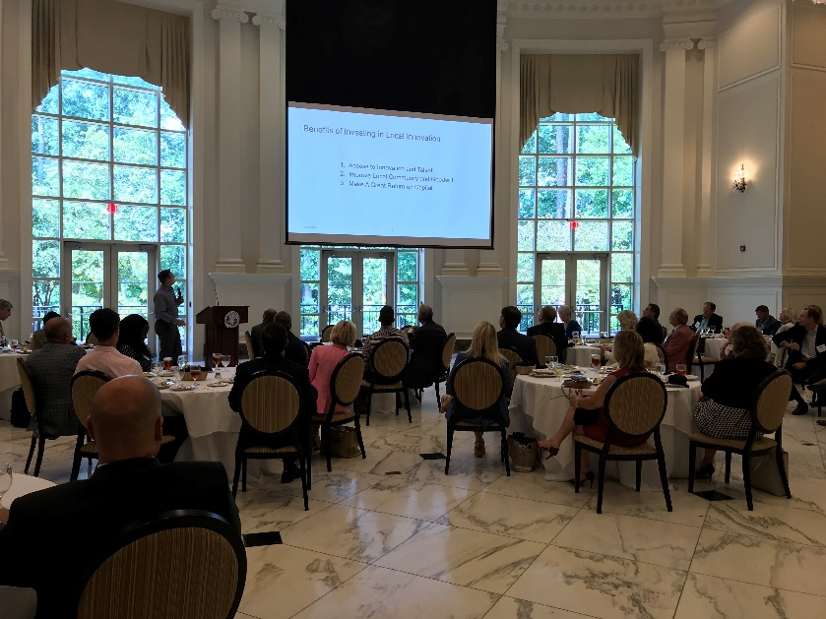

Cryptolina 18 Conference - This was June 15th. Although not interested in Cryptocurrency, we are interested in blockchain technologys which was front and center at this conference.

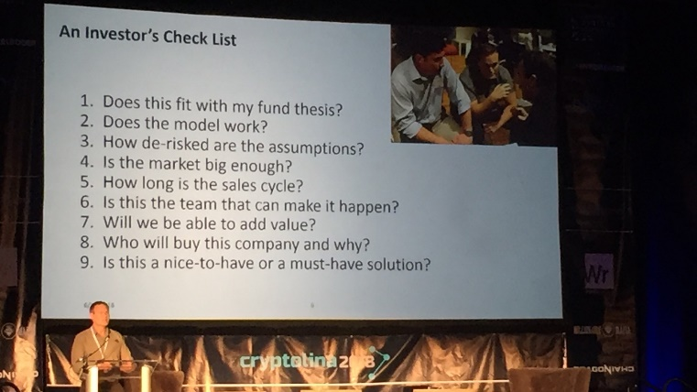

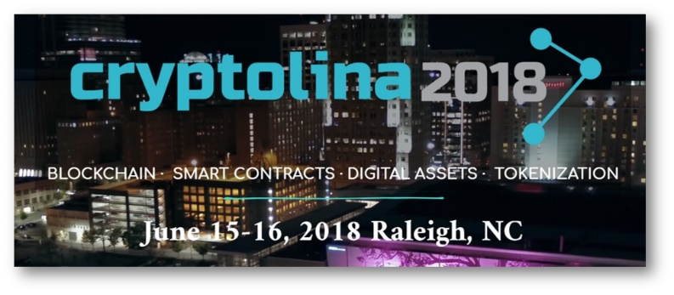

NCSU Tom Miller Fellows Program - Named after one of my professors and a man that has done so much for entrepreneurship at NCSU, this is program that I and other NCSU alum funded and support. Several graduate students working on their business plan go through the program each semester.

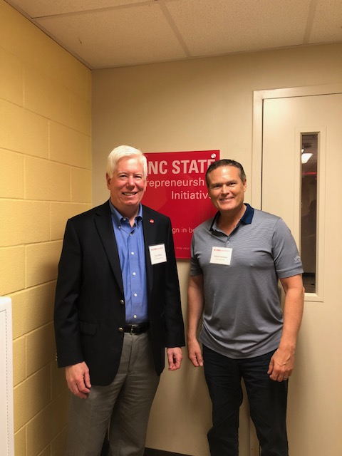

Press

WRAL – Cary-based Cofounders Partners with AI Venture Fund

TBJ – Partnership Gives Cofounders More Investing Options

WRAL Techwire – Bad Advice for Startups Article

WRAL Techwire – More Bad Advice for Startups Article

Startup Summit – Experience Gives the Test and then the Lesson

WRAL - Women Entrepreneurs in the Triangle

WRAL – What do Venture Capital Stats Mean for NC?

WRAL Techwire – Startup Summit Aims to Connect and Educate

Closing
We feel good about our investments and deal funnel. I think we are about where we anticipated to be at this stage of our second fund. Feel free to call or stop by anytime if you have questions.

Finally, I’ll leave with this picture of investor Andy Albright with Gene Simmons from KISS. It has nothing to do with my update…just thought it was cool!

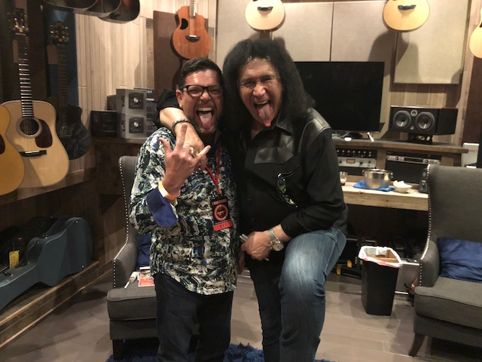

--
David Gardner Profile
david@CofoundersCapital.com
919.244.3048
Cofounders Capital
@startUpHats
The Startup Hats Book

